1.3

What is the 16 bit FP number representation of -5.375 in hex with 1 bit sign, 4 bit biased exponent, and 11 bit fraction, where bias = 7?

1.4

What is the real number equivalent to FP number 0x3400 with 1-bit sign, 4-bit biased exponent, 11-bit fraction, and bias = 7?

1.6

What is the biggest positive FP number that can be represented in 16-bit format using 1-bit sign, 4-bit biased exponent, and 11-bit fraction, where bias is 7?

1.11

Represent the following real numbers as 16-bit FP numbers with 4-bit biased exponent, bias = 8, and 11-bit fraction:

1. 1.0
2. 0.5
3. 0.25

1.12

Draw a data path similar to the one shown in Fig 1.1 that would be used to generate the result….

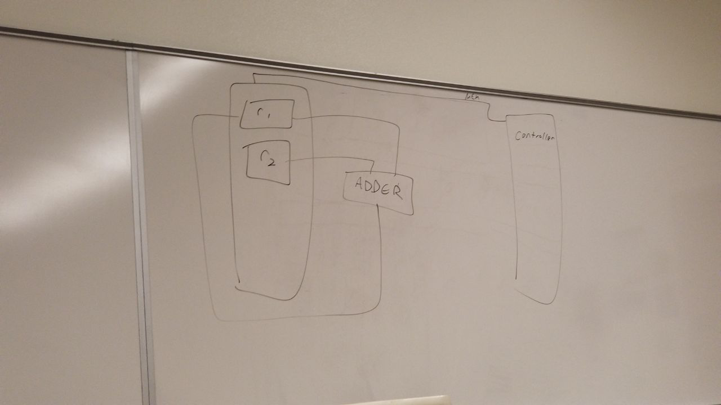pipelini

1.14

What is a Von Neumann architecture bottleneck?

1.17

What is the C in CMOS stand for, and why is that important?

1.18

What is the difference between pipelining and parallelism architecture? Identify their application areas.

Pipelining – traking sets of instructions and splitting them up into similar sets of instructions